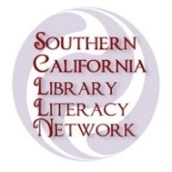 | 2017 Writer To Writer Challenge  for Adult Learners of the  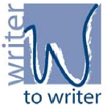  Southern California Library Literacy Network (SCLLN)

September 2017

Dear Adult Learner:

SCLLN invites you to join other Adult Learners from Southern California in the 2017 Writer to Writer Challenge. It is a chance for you to:
- share your thoughts with others in writing
- become a writer yourself
- relate what you read in a book/story or poem to your own life
- practice writing a letter, so you can write other letters on your own in the future

We hope that you and your tutor will use the Writer To Writer Challenge as part of your regular tutoring as a way to promote reading for meaning and enjoyment, and to practice writing skills.

Please take time to review the attached materials and then write a letter to an author whose writing has changed the way you think about life. Your letter is just a friendly note to a favorite author, living or dead. It can be short or long, but it must be under 500 words.

You can write about a book you have read or an audio-book you have listened to. The letter you write can be a story that you have told to your tutor as s/he writes down your words, or it can be something you have written yourself. This challenge is for everyone – from beginning to advanced level learners. The book you read or listen to and your letter must be in English. One entry per person.

To participate in the Challenge, please do the following:
- Read the Instructions and complete the Entry Form.
- Staple the Entry Form to your letter. (You may want to keep a copy of your letter.)
- Turn in your letter and form to a staff member.
- Copy your letter and form, and submit the original for judging.

Your letter must be received by Carlsbad Library Learning Center on or before
December 7, 2017

Everyone who writes a letter will receive a certificate from SCLLN. The top writer in each category chosen by a panel of other Adult Learners will win a prize. The winning letters will be published in a book and on the SCLLN website. For questions, please contact:

Carrie Scott
Carlsbad Library Learning Center
3368 Eureka Place
Carlsbad, CA 92008
760-931-4510 or carrie.scott@carlsbadca.gov

Sincerely,Writer To Writer Challenge Committee, SCLLN

